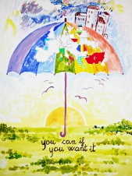
RİDİNG THE RAİNBOW TO A BETTER FUTURE

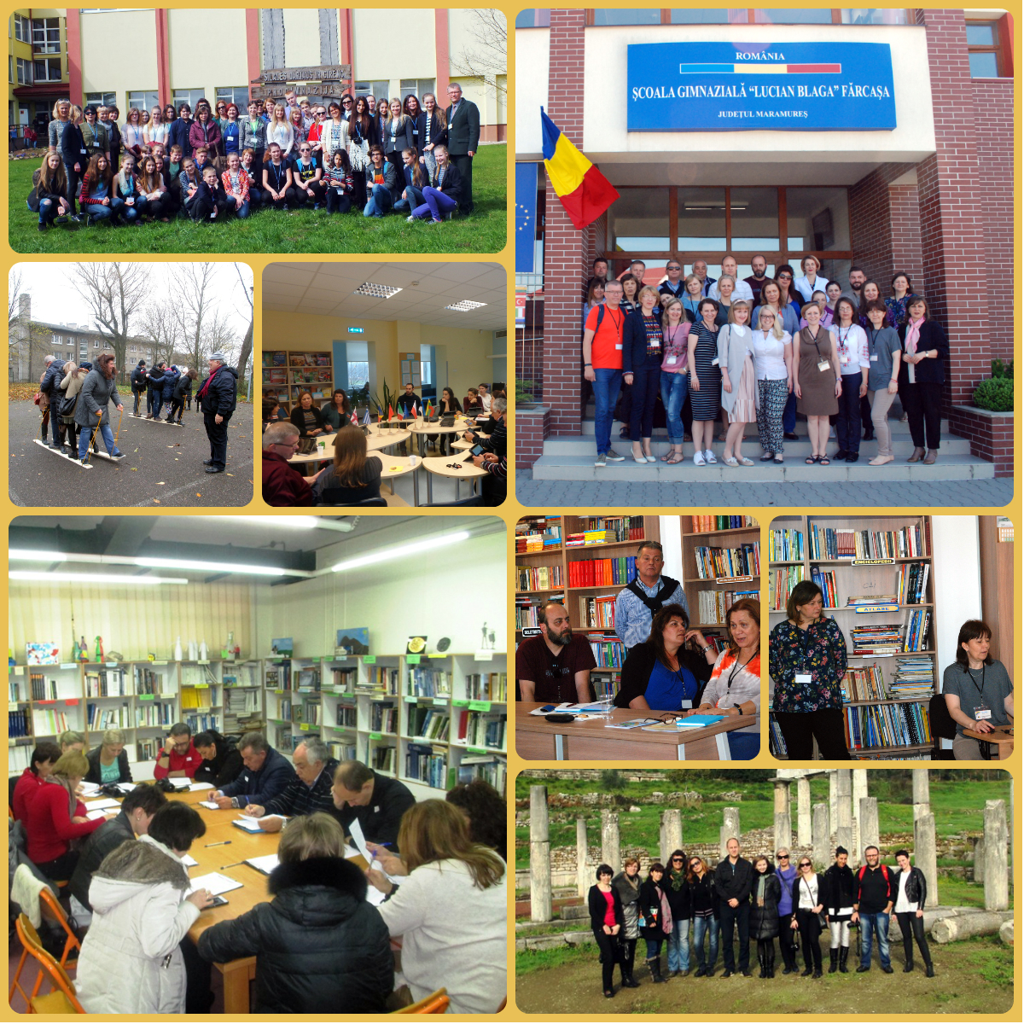

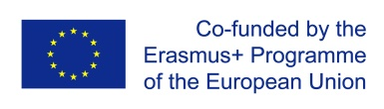
This book represents some of the hard work of seen institutions and numerous teachers united in a partnership created under the Erasmus+ KA2 Strategic Partnerships for school education. We hope the sharing of these lesson plans and worksheets will be useful to other teachers around Europe

